**Practical:1**

**Aim : Introduction of ERP**

**Enterprice Resource Planning**

To get a deeper understanding of how ERP solutions can transform your business, it helps to get a better sense of what ERP actually is and how it works. Here's a brief introduction to ERP and why it seems like everyone's talking about it.

**Enterprice Resource Planning(ERP)** is an acronym for Enterprise Resource Planning, but even its full name doesn't shed much light on what ERP is or what it does. For that, you need to take a step back and think about all of the various processes that are essential to running a business, including inventory and order management, accounting, human resources, customer relationship management (CRM), and beyond. At its most basic level, ERP software integrates these various functions into one complete system to streamline processes and information across the entire organization.

The central feature of all ERP systems is a shared database that supports multiple functions used by different business units. In practice, this means that employees in different divisions—for example, accounting and sales—can rely on the same information for their specific needs.

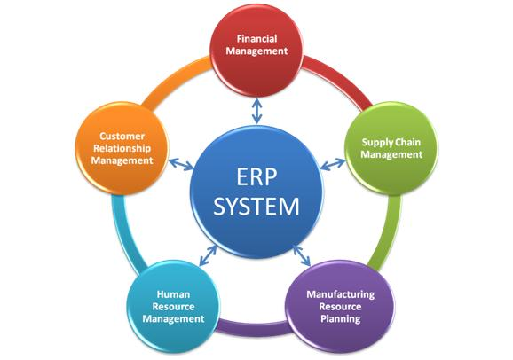

**Figure 1:- ERP System**

ERP software also offers some degree of synchronized reporting and automation. Instead of forcing employees to maintain separate databases and spreadsheets that have to be manually merged to generate reports, some ERP solutions allow staff to pull reports from one system. For instance, with sales orders automatically flowing into the financial system without any manual re-keying, the order management department can process orders more quickly and accurately, and the finance department can close the books faster. Other common ERP features include a portal or dashboard to enable employees to quickly understand the business' performance on key metrics.

**Evolution of ERP:-**

The term ERP was coined in 1990 by Gartner1, but its roots date to the 1960s. Back then, the concept applied to inventory management and control in the manufacturing sector. Software engineers created programs to monitor inventory, reconcile balances, and report on status. By the 1970s, this had evolved into Material Requirements Planning (MRP) systems for scheduling production processes.

In the 1980s, MRP grew to encompass more manufacturing processes, prompting many to call it MRP-II or Manufacturing Resource Planning. By 1990, these systems had expanded beyond inventory control and other operational processes to other back-office functions like accounting and human resources, setting the stage for ERP as we've come to know it.

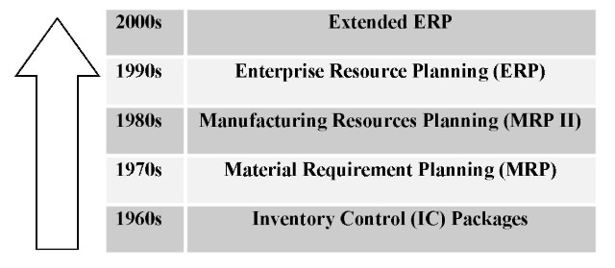

**Figure 2: Evolution of ERP system**

Today, ERP has expanded to encompass business intelligence (BI) while also handling "front-office" functions such as sales force automation (SFA), marketing automation and ecommerce. With these product advancements and the success stories coming out of these systems, companies in a broad range of industries—from wholesale distribution to ecommerce—use ERP solutions.

Moreover, even though the "e" in ERP stands for "enterprise," high-growth and mid-size companies are now rapidly adopting ERP systems. Software-as-a-Service (SaaS) solutions—also referred to as "cloud computing"—have helped fuel this growth. Cloud-based solutions not only make ERP software more affordable, they also make these systems easier to implement and manage. Perhaps even more importantly, cloud ERP enables real-time reporting and BI, making them even valuable to executives and staff seeking visibility into the business.

As a result, companies of all sizes and a wide range of industries are transitioning to cloud ERP systems. In fact, Forrester predicts that SaaS-based ERP adoption will rise 21 percent annually through 2015.2 When you stop to consider the benefits of ERP, it's easy to see why it's become so popular and why its use will continue to grow so rapidly.

**Advantages of ERP (Enterprise Resource Planning) System:**

1. Complete visibility into all the important processes, across various departments of an organization (especially for senior management personnel).

2. Automatic and coherent workflow from one department/function to another, to ensure a smooth transition and quicker completion of processes. This also ensures that all the inter-departmental activities are properly tracked and none of them is ‘missed out’.

3. A unified and single reporting system to analyze the statistics/status etc. in real-time, across all functions/departments.

4. Since same (ERP) software is now used across all departments, individual departments having to buy and maintain their own software systems are no longer necessary.

5. Certain ERP vendors can extend their ERP systems to provide Business Intelligence functionalities that can give overall insights on business processes and identify potential areas of problems/improvements.

6. Advanced e-commerce integration is possible with ERP systems – most of them can handle web-based order tracking/ processing.

7. ERP systems make it easier for order tracking, inventory tracking, revenue tracking, sales forecasting and related activities.

8. ERP systems are especially helpful for managing globally dispersed enterprise companies, better.

**Business integration using ERP**

At its core, ERP helps employees do their jobs more efficiently by breaking down barriers between business units. More specifically, an ERP solution:

* Gives a global, real-time view of data that can enable companies to address concerns proactively and drive improvements
* Improves financial compliance with regulatory standards and reduces risk
* Automates core business operations such as lead-to-cash, order-to-fulfilment, and procure-to-pay processes
* Enhances customer service by providing one source for billing and relationship tracking.

When you add up these advantages, the value of ERP—particularly cloud ERP—is clear. With an ERP solution, employees have access to accurate information that enables them to make better decisions faster. Not only that, but ERP software helps to eliminate redundant processes and systems, dramatically lowering the cost of doing business overall.

**Conventional packages vs ERP packages :**

the first difference is that ERP packages have functions not only individual businesses, such as accounts and inventory, but also the total range of man business necessary for company operation

The second difference is that ERP packages are targeted at everything from small businesses to the largest organisation, and that it can be composed of a highly flexible decentralised database and information system cluster linked by network.

**ERP Domain**

**Construction**

A construction ERP software should be able to handle each project undertaken by a company and record all details starting from bidding for the projects, project awards, project commencement, various stages of the projects, completion of the projects.

**Made to order**

The Made TO Order companies undertake production of components after orders are placed. The customer order is the starting point for such companies to begin production. Many computer manufacturing companies have a business model in which they commence computer assembly on receipt of a order.

**Made to stock**

The Made TO stock companies produce components and products on assumption that a certain number of orders will be booked in future. ERP software for such companies track their manufacturing activities and their stock levels.

**webERP**

**Introduction**

Business is changing. It is becoming more dynamic and geographically dispersed. The traditional communication tools particularly the fax machine are being displaced by email. Information is required to be available 24x7 at the click of a button via the Internet. This is a modern business system that has adapted to the new environment.

The Internet, a proliferation of TCP/IP networking computers all linked together provides a compelling infrastructure for business systems because it offers:

* Unparalleled reliability
* Low cost, wide area networking
* A common interface available on all computers - a web browser
* Minimal investment in infrastructure - the Internet is built largely on open source software

**webERP Modules**

- Purchase Module

- Inventory Module

- HR & Payroll Module

- Tools & plants Module

- Tender- Mid Module

- Sub-Contractor Payment Module

- Financial Management

- Engineering Module

- Admin Module

**Industry solutions:**

WEBERP provides these functionality to resolve industry problems :

* [Accounting](http://en.wikipedia.org/wiki/Accounting)
* [Asset management](http://en.wikipedia.org/wiki/Asset_management)
* [Customer relationship management CRM](http://en.wikipedia.org/wiki/Customer_relationship_management)
* [Human resource management HRM](http://en.wikipedia.org/wiki/Human_resource_management).
* [Manufacturing](http://en.wikipedia.org/wiki/Manufacturing)
* [Point of sale POS](http://en.wikipedia.org/wiki/Point_of_sale)
* [Project management](http://en.wikipedia.org/wiki/Project_management)
* [Purchasing](http://en.wikipedia.org/wiki/Purchasing)
* [Sales management](http://en.wikipedia.org/wiki/Sales_management)
* [Warehouse management system](http://en.wikipedia.org/wiki/Warehouse_management_system)

**Key feature of WEBERP:**

* Sales Orders and Quotations
* Accounts Receivable
* User defined sales analysis
* Multi-currency bank accounts
* Shipment Costing
* Contract Costing
* General Ledger
* Manufacturing
* Multi-language
* Multi-currency, complex tax system support
* Multiple inventory locations with serial number and lot tracking facilities
* Multiple Invoice Taxes
* Supports Materials Requirements Planning (MRP I) functionality with a master production schedule and reports suggesting purchase and works orders

**Pricing**

The script looks up the pricing for the customer based on the customer currency and sales type. As many sales types as required can be set up each with its own price list. Where there is no pricing set up for the sales type and currency of the customer then no parts are available for adding to the order.

**Kit set parts** can be entered - these are defined at the stage of the inventory item setup - they are exploded into their components for modification directly in the order. They are a short cut to selecting each individual part where only one part changes. eg a computer with xyz motherboard, case, keyboard, mouse, 256Meg RAM etc.

The kitset part could bring all these parts into the order, but then allow deletion of the 256Meg RAM and replacement with the code for 512Meg RAM or whatever modifications are required.

**Assembly parts** can also be entered that refer to underlying component parts but priced at the assembly level. An assembly part is not exploded into its components at the time of order entry like a kitset. It exists in orders and sales analysis records but not for stock quantity records maintained although movement records are created for the assembly parts as well as the components of the assembly.

**Technology**

The ERP system is based on a Mysql,Javascript,PHP based web application framework - wnframework. This framework is developed by the company and is also Open Source. The database backend currently supported is MySQL.

WEBERP hosted version is online since September 6, 2013 and so far more than 1531 users have signed up for the application. There is an automated sign-up and setup process and a thirty-day free trial.

**User of this package:**

Any newly established or small manufacturing industry can use this type of ERP.

**Company**

webERP was developed by Logic Works.

Logic Works was originally incorporated in 1997 as a limited liability vehicle for the distribution of a Microsoft Access based ERP Syetem.

This was originally a pure Microsoft Access application – but multi user issues soon became evident and the heavy network requirements for a multi-user system using Microsoft Access made this a difficult application to run by.

**Practical - 2**

**Software Requirements**

If the business elects to have their own on-site web-server there are many software bundles that will provide the necessary infrastructure of:

* PHP a versions later than 5.1
* [MySQL](http://www.mysql.com) version 4.3 or above - innodb transaction compliant tables are required

The latest binaries can be downloaded separately for both by following the above links but in a windows environment the [apache2triad bundle](http://apache2triad.net/) provides all the software required and comes with a convenient installer.

In a windows/linux/unix environment the [XAMPP](http://www.apachefriends.org/en/xampp.html) also provides all the software required and is easy to install.

Installing either of the above two server software bundles will provide all you need to get going. To get the latest and greatest revisions of the individual components you need:

* [PHP](http://www.php.net/) Any version greater than 5.1 will work. PHP works on all operating systems so webERP is therefore operating system independent. If transfer of EDI orders is required the ftp extensions for PHP will be needed. If using translations the gettext extension for PHP is also required. The graphing functions also require the GD extension.
* [MySQL](http://www.mysql.com/)-Max with Innodb transactional tables support. Innodb was introduced in 2001 to MySQL and has Oracle like functionality – with similar speed. MySQL later than version 4 has Innodb tables in by default. Since MySQL represents such good value for money it has been used. An example configuration file my.cnf normally under /usr/local/mysql/var is available in the mysql documentation to show typical settings for the Innodb configuration. The expected size of the data is useful although additional data files can be created retrospectively as necessary. Note that only the tables that require transaction support are defined as Innodb tables.
* A web server. [Apache](http://www.apache.org/) makes the most sense – but most web servers are supported by PHP in various forms.
* If the web server is accessible over the Internet and not just over a LAN then encrypted communications are required. The openssl and mod-ssl modules for apache can be easily used to ensure all data is transmitted in encrypted form.

The system could be used with many other database servers but it is tested and developed on MySQL. Independent benchmarks show that MySQL is one of the fastest for most common database tasks, particularly at establishing connections – since this is required for every page, MySQL is therefore ideally suited to the web environment. Using Apache with [mod_ssl](http://www.modssl.org/) and openssl secure sockets makes sense where there is any data transmitted over the Internet and not just over a LAN.

**Hardware Requirements**

There are many possible configurations that could run this application. The scale of the enterprise obviously will have a significant bearing on the final configuration.

Each client connection to the web server and database engine will also consume RAM so the more connections the larger the RAM requirement. Similarly disk space required is a function of the volume of customers, suppliers and transactions. Suffice it to say that due to the efficiency of the components of the system the demands on the hardware are exceptionally light by client server application standards.

As a guide, an installation for up to 50 simultaneous users could consist of the following: a Linux operating system, an Apache web server, an entry level server with 2Gig RAM and a 100 Megabit network card.

**Company Requirements:**

* Internet connection and basic network services (e.g., firewall, NAT routing, wireless access point, DHCP server, LDAP server, web server, etc.)
* E-mail Server (possibly with spam filtering and virus protection, with IMAP, POP3 mailboxes and even a web-based e-mail mail client)

# Requirements for the MYSQL Server

Depending on your system you may also need:

* 2 or more CPU cores
* 2 or more GB of RAM
* Disk I/O subsystem applicable for a write-intensive database

Recommended system reqirements

* 4 or more CPU cores.
* 8 or more GB of RAM.
* Disk I/O subsystem applicable for a write-intensive database (RAID10, RAID 0+1)

The Monitor Agent is available for a wide range of operating systems. For an up-to-date list please see the http://www.mysql.com/products/enterprise/. The agent can be used to monitor any MySQL server from version 4.0.x through 5.6.x.

### Optional for Developers

* sphinx for generating developers documentation.

**USERS**

EDO - Nicholas Gerber and Mo Mobarak contributed a substantial amount of development work undertaken by ITWorx. This contribution allowed for setting up a service based business renting hosted webERP to businesses wishing to do their accounting from anywhere free from the worry of backup and hosting a complex ERP application themselves.

**Budgeting**

webERP will help you set and manage budgets on your **Cost Centers**. This is useful when, for example, you are doing online sales and you have a budget for search ads and you want webERP to stop or warn you from over spending based on that budget.

Budgets are also great for planning purposes. When you are making your plans for the next financial year, you would typically target a revenue and based on that you would set your expenses. Setting a budget will ensure that your expenses do not get out of hand at any point based on your plans.

You can define it in the **Cost Center**. If you have seasonal sales you can also define a budget distribution that the budget will follow.

**Practical - 3**

**Aim : - Process identification of webERP.**

In this exercise we are going to see the process used in webERP for adding a new purchase order, getting the information about the purchase order, canceling the purchase order, receiving purchase order and much more.

**Adding a New Purchase Order**

To add a new Purchase Order, Click on Main menu.

* Select the Purchasing Module
* Click on Add Purchase Orders
* Enter the suppliers name or supplier code and click search.
* Select the supplier from whom you want to purchase.
* Fill in the information for both the supplier and warehouse where the goods are going to be delivered.

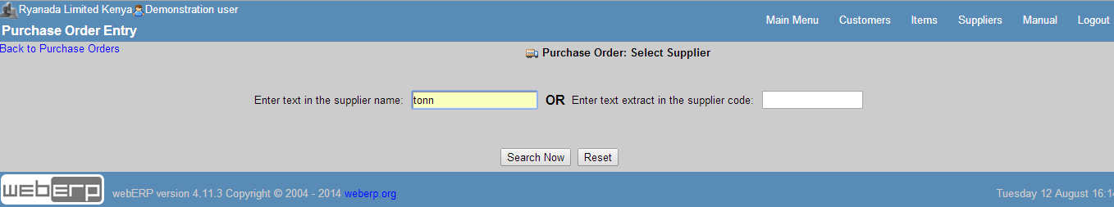

**Figure 1 – New purchase order window**

The purchase order date, delivery date, Requisition Ref, warehouse name, Address lines 1 to 4, telephone number, and the deliverers ) Then the supplier information that need to be entered include the address line 1to 4 that needs to be entered , the phone number, the payment terms , and there is a field to type in any comments if necessary.

* Click Enter line items.
* This will allow you to select the stock category for the stock items you want - you can elect to choose "All" stock categories to list all stock
* Click Search Now, a list showing the items meeting the criteria will display
* It is possible to enter the quantity you require in the quantity field in the list. Be aware that this is the supplier's unit quantity that is being entered here
* Click order some - all the lines with a quantitiy entered will come up in the order at the current supplier purchasing price. if no purchasing data is set up for the item/supplier, then the purchase price will need to be entered manually.
* Click on "Update Order Lines" to recalculate the extended amount of the order
* Then click "Process Order"

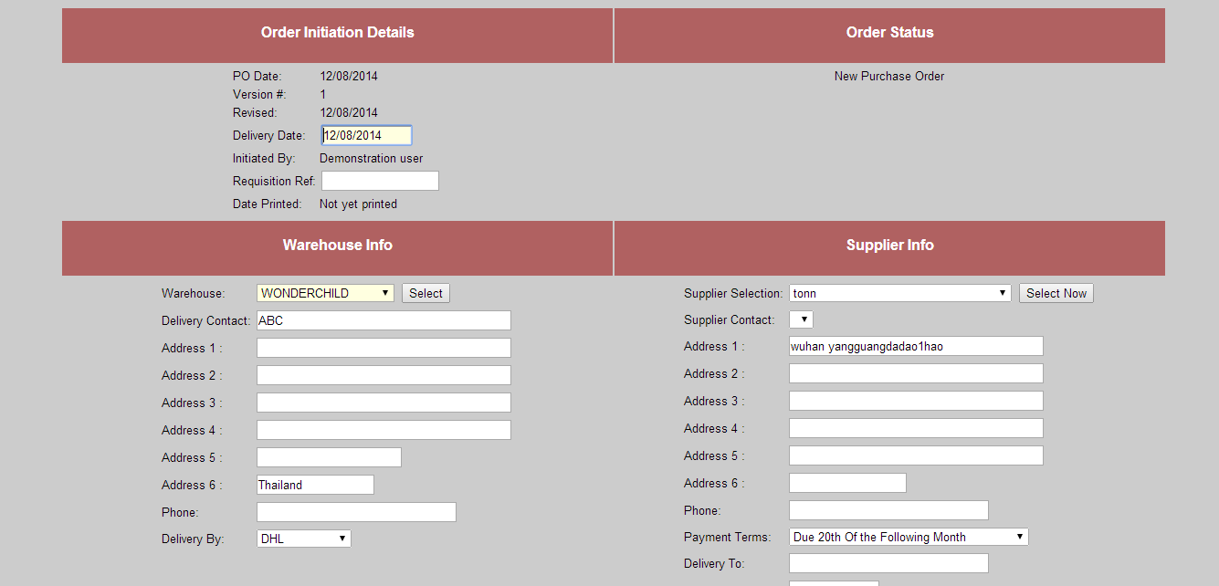

**Figure 2 – New purchase order window**

A success report should display showing that you have created a purchase order.

**Purchase Orders Status**

The order status starts off as:

* Pending - the order has been created but not authorised
* Authorised - the order has been authorised but not printed
* Printed - the order has been authorised and printed and is ready to receive
* Cancelled - the order has been cancelled. Cancelled orders are not deleted, they are retained for audit purposes - who cancelled it and the date is available for inspection in the status comments field
* Rejected - if an authorisor disagrees with the requirement to purchase this order the status of the order is changed to rejected. In many respects this status is treated the same as cancelled
* Completed - the order is fully received or no more will be received on the order. webERP maintains changes the status to completed when all lines of the order are fully received - or the line is amended to have the same amount as already received.

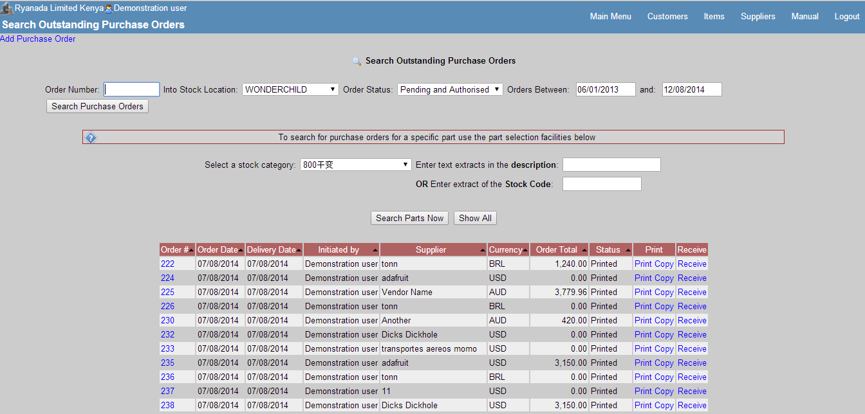

**Figure 3- Purchase order tracking window**

**Authorising Purchase Orders**

Here the directors and authorising officials will log into webERP to look for purchase orders that have been raised and they will either cancel, reject, or authorise these purchase orders.

Below are the steps of authorising purchase orders

* Click on Main menu
* Click on Purchases
* Click on Orders to Authorise
* The status of the purchase orders will be pending
* Drop this down and select authorise
* Click update

This will enable the person who created purchase orders to print and receive them. In order to Receive a purchase order, it has to be printed first and sent or emailed to the supplier

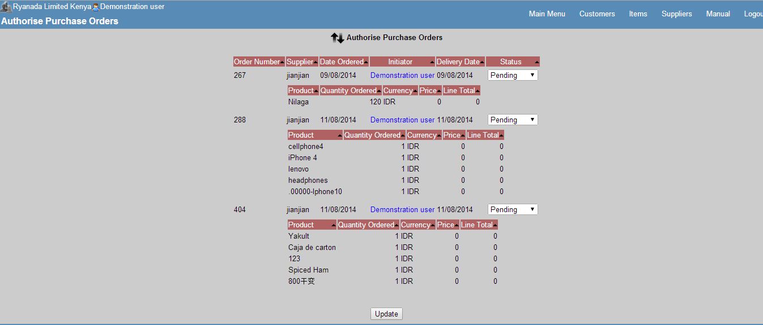 **Figure 4 – Authorising purchase order**

**Recieving Purchase Orders**

* When the supplier delivers the goods to the warehouse , the stock manager will log into webERP
* Click main menu -> Purchasing Module
* Clik Purchase orders and enter criteria to select the purchase order you require
* Assuming the order is authoirsed and printed there will be an option to "Receive" - click Receive
* The Goods Received screen shows and allows the quantities received to be entered. This quantity will show in the businesses units of measure but the conversion and the quantity in the suppliers unit of measure will also show.
* If the item being received is a controlled item, the batches/rolls/lots/serial numbers being received need to be specified individually and the system keeps track of how many in total are being received.
* Only the quantity received should be entered, this may well be different to the original order quantity because the supplier might not deliver all the ordered items at the same time, and at this point we need to record exactly what has been delivered, and not what has been ordered. He might deliver in parts. So these changes are supposed to be effected at this point before processing a Goods Received Note.
* Then click update.
* Click on Process a Goods Received (GRN), finally click on Print a Goods Received Note (GRN).

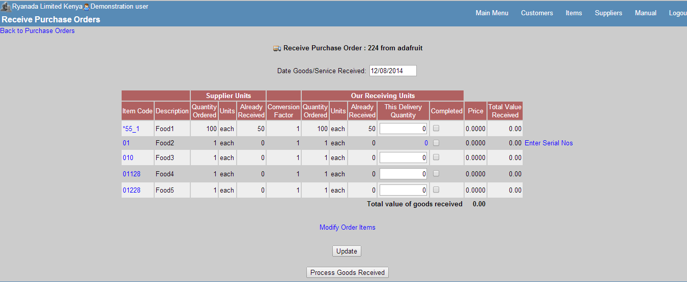

**Figure 5 – Receive purchase order window**

Setting up a work order is performed from the Manufacturing tab -> transaction entry -> Work Order Entry. The work order number is automatically maintained and defaulted for new work orders as is the start date defaulted to the date the work order was created. Other data required includes:

* Factory location - this is the inventory location which is used to retrieve the bill of materials for the items being manufactured on the work order - it is possible to have different bills of material for the same item depending on the inventory location. This inventory location is also used as the default location where materials for the work order are issued from and the default location where manufactured items are received into. It is possible to modify this during the issuing and receive processes.
* Required By - this is the date when the manufacturing must be completed by

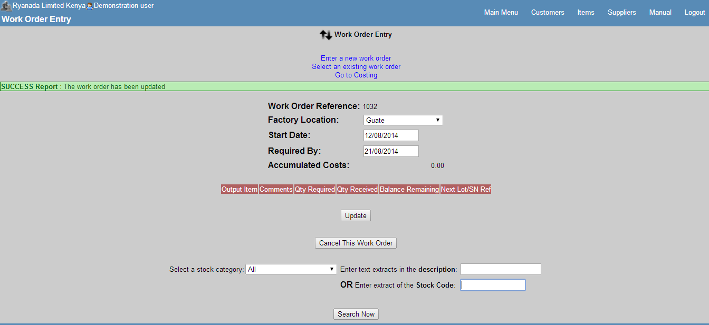

**Figure 6 – Receiving purchase order window**

**Work Order Entry**

The Work Order is the medium for issuing components/raw materials to. A running total of the costs issued to the work order is maintained. Work orders can be created that have any number of output items. Output items are restricted to only "manufactured" items as defined in the item entry form. The work order tracks the quantity of the output items received against the work order and checks that no more than the work order quantity originally set up, with an allowance including the over-receive proportion as defined for purchase orders, is received.

Setting up a work order is performed from the Manufacuting tab -> transaction entry -> Work Order Entry. The work order number is automatically maintained and defaulted for new work orders as is the start date defaulted to the date the work order was created. Other data required includes

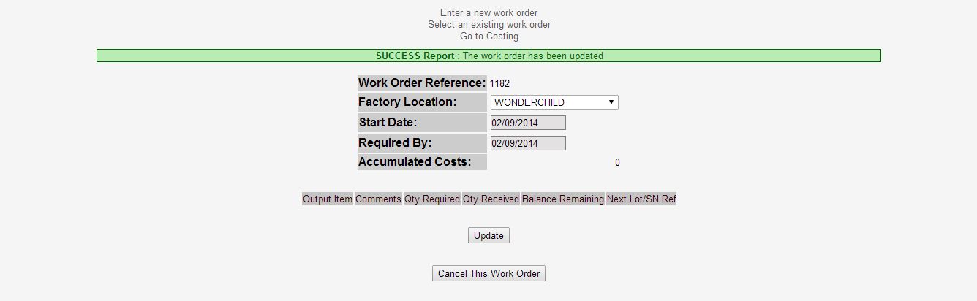

**Material Requirements Planning (MRP)**

It is one thing to plan for purchasing where the item being sold is the item to be purchased. Things get more complicated when the item being sold is manufactured - each of the components in the bill of material need to be available before the item being sold can be manufactured. Where the components in turn are also manufactured then the complexity compounds - this is the material requirements planning calculations are for.

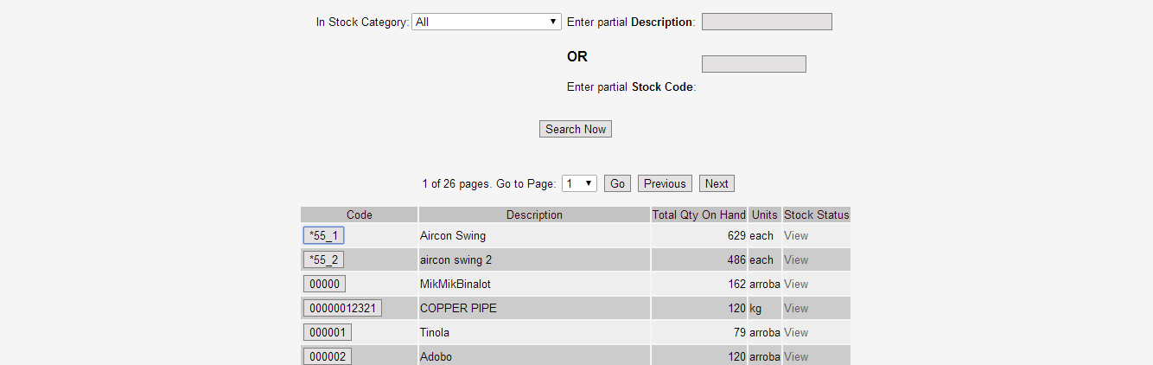

**Inventory Adjustments**

Inventory can be written on or off for individual stock items using this option. Corrections to physical stocks and deliveries of stock can be entered using this option. Adjustments can be entered by selecting the link on the SelectProduct.php page or directly from the menu under transactions. Using the second link, the item code must be known, there is no facility to select an item code from this page.

**Practical 4**

**Aim:-Introduction to Business Process Re-Engineering(BPR)**

Business process re-engineering is a [business management strategy](http://en.wikipedia.org/wiki/Strategic_management), originally pioneered in the early 1990s, focusing on the analysis and design of [workflows](http://en.wikipedia.org/wiki/Workflow) and [business processes](http://en.wikipedia.org/wiki/Business_process) within an organization. BPR aimed to help [organizations](http://en.wikipedia.org/wiki/Organization) fundamentally rethink how they do their work in order to dramatically improve [customer service](http://en.wikipedia.org/wiki/Customer_service), cut [operational costs](http://en.wikipedia.org/wiki/Operational_costs), and become world-class [competitors](http://en.wikipedia.org/wiki/Competitor). In the mid-1990s, as many as 60% of the [Fortune 500](http://en.wikipedia.org/wiki/Fortune_500) companies claimed to either have initiated reengineering efforts, or to have plans to do so.

BPR seeks to help companies radically restructure their organizations by focusing on the ground-up design of their business processes. According to Davenport (1990) a business process is a set of logically related tasks performed to achieve a defined business outcome. Re-engineering emphasized a [holistic](http://en.wikipedia.org/wiki/Holism) focus on business objectives and how processes related to them, encouraging full-scale recreation of processes rather than iterative optimization of sub processes.

Business process re-engineering is also known as business process redesign, business transformation, or business process change management.

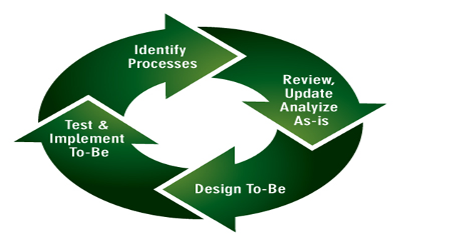

**Figure 1 – Business Process Re-engineering**

**Comparison of BRP with Total Quality Management**

Both TQM and BPR are customer-oriented. They both aim on improving the customer satisfaction. Also, they both suggest thinking outside in. On the other words, they both suggest to think from the customer's viewpoint. Also, both TQM and BPR are process-oriented. They both target to alter the processes, but not just on the product. Moreover, they both take team approach.

Nearly all BPR projects are initiated by top-down approach. Since BPR would results great changes, staff resistance is obvious. Therefore, top management's support and commitment are very important. For TQM, both top-down approach and bottom-up approach are possible.

The basic assumptions of TQM and BPR are different. TQM assumes that the existing practices or systems are principally right and useful. The target of TQM is to improve on the basis of the existing system. However, BPR takes an opposite assumption. BPR assumes the existing system is useless and suggests starting it over. Unlike TQM that aims on smoothly and incremental improvements, BPR aims on dramatic results.

TQM emphasis on total involvement, including all the stakeholders. The involvement even extends to suppliers and customers. Also, TQM also suggests involving all the processes in the company, including human resources management, order fulfilling, manufacturing, marketing and customer management and others. However, for BPR, the project can be controlled to a specified area only.

Standardization is one of the key points of TQM. TQM aims on standardize the practices, thus achieving a consistent performance. It also makes that there is a certain degree of documentation for TQM. However, BPR emphasis on flexibility and believes that standardization would increase the complexity of the process. Therefore, standardization is rare in BPR and the level of documentation is much lower.

TQM emphasis on the use of statistical process control. However, there is no similar concern for BPR. On the other hand, BPR emphasis more on the enabling role of information technology.

TQM is a cultural issue. Once the culture is built, TQM is absorbed in the daily operation. However, BPR is a project. It is with a clear target that should be achieved as soon as possible.

In fact, BPR is a risky project that is suitable for organizations in deep trouble or facing great challenges. However, an organization cannot always be under BPR. TQM, on the other hand, can be treated as a consolidation approach for the organizations to maintain continuously improvements. As a conclusion, I want to share some of my personal feeling on TQM and BPR. They just like Chinese Kung Fu. There are 'hard' school and 'soft' school of Kung Fu. They are with the same purpose. BPR is just like the 'hard' school of Kung Fu. It is efficient and looks attractive. However, if it is not used carefully, it may be harmful to the own health. TQM, on the other hand, is the 'soft' school of Kung Fu. It needs a long time to practice but it can make one's body healthy too.

**Connection with Erp**

Five reasons why Business Process Reengineering should happen before your ERP implementation.

**1. Maintain your competitive advantage.** Yes, your current enterprise systems are probably a mess . . . if they even exist. You probably have a ton of spreadsheets, manual workarounds and other inefficiencies that make you wonder how your organization has managed to survive and thrive for this long. But you probably also have business processes that give you a competitive edge, no matter how painful or inefficient they may be. Business process reengineering without the constraints of software configuration ensures that you maintain these competitive advantages as you select and implement your new ERP systems.

**2.** **Mitigate the downside of the flexibility of modern ERP systems.** Most of today’s ERP systems are very flexible. In fact, I have read that the average [SAP implementation](http://panorama-consulting.com/services/erp-software-implementation/sap-implementation/) requires 10,000 configuration decisions in order to assemble a working, end-to-end process flow. If your business processes are not well defined and documented prior to implementation*,* these thousands of configuration decisions will be made in a vacuum by software techies. SaaS and cloud ERP systems are becoming more flexible as well, so even the SaaS bandwagoners will have trouble disputing this point (although I’m sure at least one will try in the comments section below).

**3.** **Best practices are a farce, but lean Six Sigma isn’t.** Best practices are a lot like unicorns and Santa Clause – they sound mythical, magical, and represent what we all hope really exists, but then we realize one day that they don’t. Best practices sound good in theory, but the reality is that they are simply best practices for how any particular ERP vendor’s software works rather than for your operations. An exception to this rule is vanilla, back-office functions such as HR and accounts payable. Lean Six Sigma, on the other hand, is a set of tools that can be used to define your own set of best practices, efficiencies, and competitive advantages that you likely don’t want to be replicated by industry peers. The graphic below illustrates some of the lean Six Sigma activities that Panorama’s team has built into its business process reengineering methodology:

**4. Faster realization of business process improvements and business benefits.** When we help clients identify process improvements, we often find that although a new ERP system may help automate and further enable process changes, many improvements can be rolled out independent of the chosen ERP software. For example, if a company decides that it wants to incorporate a purchase order approval workflow to institute tighter controls on procurement costs, it may decide to do so via email approvals until a more robust ERP system is in place to further automate this change. In addition, from an [organizational change management](http://panorama-consulting.com/services/organizational-change-management/) perspective, “spoon feeding” changes to employees sooner is more effective than waiting to implement a massive degree of change all at once during an ERP implementation.

**5. Avoid the “paving the cowpaths” trap.** Companies that fail to define business process improvements prior to their implementations are much more likely to simply automate their existing broken processes, the reason? Once an implementation starts, the meter is running on expensive technical consultants, so every minute spent making process decisions or agreeing to changes costs time and money. This set-up forces most project teams into the path of easiest resistance (i.e., simply configuring or customizing the software to fit existing processes). On the other hand, companies that take the time to define processes up front ultimately end up accelerating their implementation durations and minimizing extra costs, allowing the technical resources to focus on how the software can be best configured to meet those processes.

**Advantages of BPR**

* BPR revolves around customer needs and helps to give an appropriate focus to the business.
* BPR provides cost advantages that assist the organisation's competitive position.
* BPR encourages a long-term strategic view of operational processes by asking radical questions about how things are done and how processes could be improved.
* BPR helps overcome the short-sighted approaches that sometimes emerge from excessive concentration on functional boundaries. By focusing on entire processes the exercise can streamline activities throughout the organisation.
* BPR can help to reduce organisational complexity by eliminating unnecessary activities.

**Disadvantages of BPR**

* BPR was sometimes seen (incorrectly) as a means of making small improvements in existing practices. In reality, it should be a more radical approach that questions whether existing practices make any sense in their present form.
* BPR was often perceived (incorrectly) as a single, once-for-all cost-cutting exercise. In reality, it is not primarily concerned with cost cutting (though cost reductions often result), and should be regarded as on-going rather than once-for-all. This misconception often creates hostility in the minds of staff who see the exercise as a threat to their security.
* BPR requires a far-reaching and long-term commitment by management and staff. Securing this is not an easy task, and many organisations have rejected the whole idea as not worth the effort.
* In many cases business processes were not redesigned but merely automated.
* In some cases the efficiency of one department was improved at the expense of the overall process. To make BPR work requires a focus on integrated processes (as discussed above) that often involves obliterating existing processes and creating new ones.
* Some companies became so focused on improving internal processes that they failed to keep up with competitors' activities in the market.

**Practicals : - 5**

**Aim: - Establishing New System as BPR and Impact Analysis of new**

**System as BPR**

**Business process reengineering (BPR)** is, in computer science and management, an approach aiming at improvements by means of elevating efficiency and effectiveness of the business process that exist within and across organizations. The key to BPR is for organizations to look at their business processes from a "clean slate" perspective and determine how they can best construct these processes to improve how they conduct business.

Business process reengineering is also known as BPR, Business Process Redesign, Business Transformation, or Business Process Change Management. Reengineering is a fundamental rethinking and radical redesign of business processes to achieve dramatic improvements in cost, quality, speed, and service. BPR combines a strategy of promoting business innovation with a strategy of making major improvements to business processes so that a company can become a much stronger and more successful competitor in the marketplace.

**Business process reengineering (BPR)** :

**Steps to implement BPR in a new system**

**Phase 1:** **Begin Organizational Change**

The first step is to take a long, hard look at how the organization operates. The focus of this examination is on the operating procedures and the bottom-line results that are generated by them. The purpose of performing the analysis described below is to determine whether dramatic change by doing BPR is really necessary. It may be that only marginal change (the result of Continuous Process Improvements, Total Quality Management, and other similar programs) is needed -- which would expose the change initiative and the organization to much less risk.

**Phase 2: Build the Reengineering Organization**

An infrastructure must be established to support reengineering efforts. Although this phase consists of only a few tasks, it has a tremendous impact on the success of a BPR endeavor. Who are the people that will be chartered to reengineer the business? What will their responsibilities be? Who will they report to? These are the questions that must be answered as the reengineering staff is gathered together to communicate, motivate, persuade, educate, destroy, create, rebuild, and implement.

**Phase 3: Identify BPR Opportunities**

In this phase, we begin to break away from normal patterns of identifying business opportunities. We start by dividing the entire organization into high-level processes rather than the usual vertical business areas such as marketing, production, finance, etc. These processes, usually less than a dozen, are the major or core processes of the organization. This activity is not a time consuming task, but it is difficult because it requires a shift in how we think of ourselves. One goal here is to identify the process boundaries which will help set the project scope for those processes that are to be reengineered.

**Phase 4: Understand the Existing Process**

Now that we know which process to reengineer, we need to take a look at *why* we currently perform the process the way we do. Understandis a key word here. We may not need to scrutinize every detail of how we are performing the process -- this effort has the potential to go on indefinitely, sometimes referred to as analysis paralysis*,* which can weaken the momentum needed to carry the project all the way to implementation. What we need to do is understand the underlying reasons why the existing process is carried out the way it is, so that we can question those assumptions during our reengineering sessions later on.

**Phase 5: Reengineer the Process**

During this phase, the actual "reengineering" begins. We’ve moved from strategy and analysis phases into the redesign phase. The Reengineering Team that was formed to take part in the reengineering sessions should consist of designers and implementers, including people well versed in technology. These team members should come from both inside and outside the existing process.

**Phase 6: Blueprint the New Business System**

Blueprints are detailed plans required to build something in accordance with the designer’s intentions. In BPR, blueprints must be created to identify all the necessary details of the newly reengineered business system and ensure it will be built as intended. This phase of the project takes the reengineered process developed in the previous phase, and provides the details necessary to actually implement it.

**Phase 7: Perform the Transformation**

Now we are ready to transform the organization. We have communicated, strategized, analyzed, reengineered, and blueprinted our ideas for the new process. This is where all of the previous efforts are combined into an actual business system -- something we can see and feel and use to enable our organization to meet the market demands of today and tomorrow.

**Impact analysis of New System as BPR**

Business process reengineering (BPR) began as a private sector technique to help organizations fundamentally rethink how they do their work in order to dramatically improve customer service, cut operational costs, and become world-class competitors. A key stimulus for reengineering has been the continuing development and deployment of sophisticated information systems and networks. Leading organizations are becoming bolder in using this technology to support innovative business processes, rather than refining current ways of doing work.

**The Roles Of Leaders And Managers**

Many articles point out that BPR must have the full support of top management to succeed. If resistance is encountered, the leader must be willing to "drive" change, even to the point of ruthlessness. One article even exhorts the leader to emulate a private detective -- such as Philip Marlowe -- who adheres to the following "heroic" qualities; Relentless adherence to what is right; Courage -- moral as well as physical; Recognition that surface appearance is often an illusion; A dogged determination to get at the deeper truth. Managers in a company undergoing reorganization must work to quell the fears of employees and resistance to change (despite the fact that they may have their own apprehensions.)

According to one executive with BPR experience, "Once the [reengineering] plan is in place, you've got to pull out the stops and execute it. You cannot live in limbo between what you used to do and what you're going to do." Otherwise, the dramatic results are sacrificed, people lose their focus, and "reengineering slips into process improvement." Employees may be enthusiastic about reengineering during the initial phases if they view it as a "win- win" situation. Some companies experience resistance in later stages when employees begin to harbor doubts about the impact of reengineering, and managers are forced to adopt a more "insistent" policy

CSC Index points to poverty of ambition as a reason why BPR projects fail. "Companies that just flirt with [reengineering] suffer the pains without the gains." Reengineering advocates urge management to pull out all the stops and implement change on a grand scale. Managers in the organizations after reengineering are compared to coaches. They do not order; they guide. They do not direct the work of others; they coordinate, facilitate and empower.

**Positive Impact of new System as BPR**

**BPR Places the Customer at the Center by Breaking down Organizational Barriers**

Service organizations can put their professed commitment to customer satisfaction into action by placing the customer at the center of the reengineering process. Service workers are often unable to satisfy the customer because they must follow strictly defined rules, and they lack the authority to make exceptions or the resources to complete a transaction.

Robert Janson points to three basic principles that provide the foundation for service organizations seeking to reengineer:

* Make the customer the starting point for change -- by identifying customer wants and creating the infrastructure to support these expectations
* Design work processes in light of organizational goals
* Restructure to support front-line performance.

**Growth of Knowledge**

In this case it is much more important to get a widespread knowledge of the whole process and there are no such things as "mastering" a job; as a worker's expertise and experience grow, his or her job grows with it.

**Satisfaction**

A big advantage of reengineering is that the work becomes more satisfying because the workers get a greater sense of completion, closure, and accomplishment from their jobs. More important is the fact to satisfy the customer needs.

**Authority**

In a traditional oriented company the management expects from the employees that they follow some specific rules. In contrast to that the reengineered companies "don’t want employees who can follow rules; they want people who will make their own rules.

As management invests teams with the responsibility of completing an entire process, it must also give them the authority to make the decisions needed to get it done."

**DELL Incorporated**

Michael Dell is the founder and CEO of DELL Incorporated, which has been in business since 1983 and has been the world's fastest growing major PC Company. Michael Dell's idea of a successful business is to keep the smallest inventory possible by having a direct link with the manufacturer. This reduces the cost for inventory tracking and massive warehouse maintenance.

Michael Dell is now concentrating more on customer service than selling computers since the PC market price has pretty much equalized. Michael Dell notes:"The new frontier in our industry is service, which is a much greater differentiator when price has been equalized. In our industry, there's been a pretty huge gap between what customers want in service and what they can get, so they've come to expect mediocre service.”

Michael Dell understands the concept of BPR and really recognizes where and when to reengineer his business.

## Critiques for BPR

Reengineering assumes that the factor that limits an organization's performance is the ineffectiveness of its processes (which may or may not be true) and offers no means of validating that assumption.

Reengineering assumes the need to start the process of performance improvement with a "clean slate," i.e. totally disregard the *status quo.*

According to Eliyahu M. Goldratt (and his Theory of Constraints) reengineering does not provide an effective way to focus improvement efforts on the organization's constraint.

**Higher Demands to the Workers**

* Empowering the workers is an inevitable step in a reengineered process. Therefore the companies which hire new workers have to consider additional criteria’s in their hiring. "It is not longer enough merely to look at prospective employees' education, training, and skills; their character becomes an issue as well. Are they self-starting? Do they have self-discipline? Are they motivated to do what it takes to please the customer?" This might be more complicated to find the right people for one specific job. The worker has to be a kind of "All-rounder" which can perform several jobs.
* "For multidimensional and changing jobs companies don’t need people to fill a slot, because the slot will be only roughly defined. Companies need people who can figure out what the job takes and do it, who can create the slot that fits them. Moreover, the slot will keep changing

**Examples of negative Impact in BPR**

**Failure of Business Process Reengineering Projects in Nigerian Banking System**

Despite the sound theoretical background and striking results, business process reengineering has not always led to stellar performance. In fact, Bashein et al (1994) showed that only 30% of BPR projects achieved performance breakthrough.

Reasons for large failure include:

1. Lack of sustained management commitment and leadership
2. Unrealistic scope and expectation
3. Resistance to change.
4. Non-encouragement to conceptualization of business process
5. Non-detailing of rewards and recognition with new business process.

**Practical - 6**

**Case Study** - **webERP implementation by Reptobike.**

**About RaptoBike**

RaptoBike is a Dutch company that focuses on building qualitative yet affordable and practical recumbents. All bikes have been and will be well designed, well made, have high quality components and a very attractive price.

The company was started in January 2006. Since then we have focused on bringing our Low Racer to market, developing our plans for High Racers and Velomobiles and starting to build our network.

In June 2007 we launched our first bike : the Low Racer. We chose the main Dutch recumbent event for this. At Cycle Vision 2007 the public was able to see our bikes for the first time and even test drive our prototypes. The Low Racer is a very succesfull bike, there are a few hundred roaming the earth now.

In 2009 I quit my daytime job and focussed 100% on RaptoBike

In 2010 the Mid Racer was launced. The next step, but a full member of the RaptoBike family with it's front wheel drive system. A flexible frame that can be used for racing, touring or as a fast commuter.

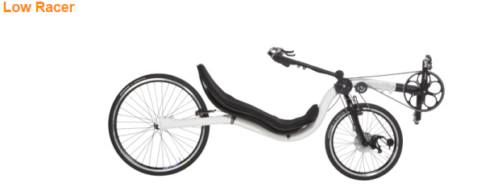

**Figure 1 - Product manufactured by Reptobike**

They were certain that their bikes offer unique qualities and are competitively priced. All of their efforts during the design phase are focused on the 'manufacturability', thus keeping the cost down. Next to this they try to keep their prices as low as possible, partly by saving costs in the manufacturing.

By maintaining low prices they hope to reach a larger group of potential recumbent riders making it more attractive to start riding a recumbent or to buy the bike people have always dreamed of.

**Business Issues**

Raptobike had to manage data sitting in an enterprise data warehouse. More valuable insight was needed from this data in order to improve outbound sales performance. More advanced customer segmentation, clustering and analytical techniques were needed to start making relevant offers to customers who have high propensities to purchase.

**Solution**

webERP

**Discription**

Raptobike were certain that their bikes offer unique qualities and are competitively priced. All of their efforts during the design phase were focused on the 'manufacturability', thus keeping the cost down. Next to this they try to keep their prices as low as possible, partly by saving costs in the manufacturing.

By maintaining low prices they hope to reach a larger group of potential recumbent riders making it more attractive to start riding a recumbent or to buy the bike people have always dreamed of.

All this requirements were satisfied by the webERP.

**Why webERP?**

as we have stated earlier that webERP is considered as a best solution for any newly established industry reptobike has also attempted to use webERP due to the following reasons.

* There are no fees associated with using the system.
* There is competition between service providers to provide the best and most cost effective support.
* Service providers are more readily available because the availability of the source code enables those with PHP knowledge (the web-programming language used by webERP) to be able to identify exactly what processing is performed by the system.
* The source code is not available with proprietary systems, sometimes not even to licensed support providers - they need to communicate back to the software vendor for a response. With the information available to support people, even within the business, the quality of the support is logically, likely to be better.
* The software can be made to perform exactly as the business requires it to without breaking the bank.
* webERP has a wide variety of features suitable for managing businesses of many differing forms. From the face of a simple menu structure, complex business processes are easily accessible - such as multiple inventory locations, multiple currencies, lot and serial number tracking of inventory.
* All features are integrated with each other. Inputs are required just once. Everywhere the change is propagated across the system.

**Practical – 7**

**Case study:** Study of ERP Implementaion Life-cycle.

**Introduction**

Tougher competition in the marketplace is generating the need to better optimize resources, improve profitability and keep customers satisfied. Companies are increasingly implementing Enterprise Resource Planning (ERP) software solutions to improve operations and provide faster customer response. Choosing an ERP solution that meets your *specific* business requirements will enable you to have a smoother implementation. If the software package is written for your industry, you won’t have to custom design a solution. Customized solutions are time consuming to implement and add unnecessary cost. One of the top reasons ERP implementations fail is because the software doesn’t meet basic industry specific business requirements. However; purchasing an ERP application is only half the battle. A well designed implementation plan is the key to success.

**STRATEGIC PLANNING**

Assign a project team.

• Examine current business processes and information flow.

• Set objectives.

• Develop a project plan.

Project team: Assign a project team with employees from sales, customer service, accounting, purchasing, operations and senior management. Each team member should be committed to the success of the project and accountable for specific tasks, i.e. developing a timeline, finalizing objectives, formulating a training plan. Make sure you include first line workers as well as management on your team. Base the selection on the knowledge of the team not status of the employee.

Examine current business processes: Have the team perform an analysis on which business processes should be improved. Gather copies of key documents such as invoices, batch tickets and bill of lading for the analysis. To start the team discussion, consider questions such as: Are your procedures up to date? Are there processes that could be automated? Are personnel spending overtime processing orders? Does your sales force and customer service personnel have real-time access to customer information? The team members should also conduct interviews with key personnel to uncover additional areas of improvement needed.

Set objectives: The objectives should be clearly defined prior to implementing the ERP solution. ERP systems are massive and you won’t be able to implement every function. You need to define the scope of implementation. Ideally, the scope should be all inclusive. But practically, it is very difficult to implement. Examples of objectives would include: Does the solution reduce backlogs? Can the solution improve on-time deliveries? Will you be able to increase production yields?

Develop a project plan: The team should develop a project plan which includes previously defined goals and objectives, timelines, training procedures, as well as individual team responsibilities. The end result of the project plan should be a “to do” list for each project team member.

**PROCEDURE REVIEW**

Review software capabilities.

• Identify manual processes.

• Develop standard operating procedures.

Review software capabilities: Dedicate 3-5 days of intensive review of the software capabilities for the project team. Train on every aspect of the ERP software to fully educate the team on capabilities and identify gaps. Determine whether modifications are needed prior to employee training.

Identify manual processes: Evaluate which processes that are manual and should be automated with the ERP system.

Develop standard operating procedures (SOPs): for every aspect of your business. These procedures should be documented. Make sure that you modify the document as your SOPs change. This is a huge task, but it is critical to the success of your implementation.

Examples of SOPs:

• How do you handle global price changes?

• What are the processes for inputting new customer records?

• How do you currently handle the paperwork on drop shipments?

• How do we add a new product or formula?

**DATA COLLECTION & CLEAN-UP**

• Convert data.

• Collect new data.

• Review all data input.

• Clean-up data.

Convert data: You can’t assume 100% of the data can be converted as there may be outdated information in the system. Determine which information should be converted through an analysis of current data.

Collect new data: Define the new data that needs to be collected. Identify the source documents of the data. Create spreadsheets to collect and segment the data into logical tables (Most ERP systems will have a utility to upload data from a spreadsheet to their database).

Data clean-up: Review and weed out unneeded information such as customers who haven’t purchased in a while or are no longer in business. Now is the time for improving data accuracy and re-establishing contact with inactive customers.

**TRAINING AND TESTING**

Pre-test the database.

• Verify testing.

• Train the Trainer.

• Perform final testing.

Pre-test the database: The project team should practice in the test database to confirm that all information is accurate and working correctly. Use a full week of real transaction data to push through the system to validate output. Run real life scenarios to test for data accuracy. Occurring simultaneously with testing, make sure all necessary interfaces are designed and integration issues are resolved to ensure the software works in concert with other systems.

Verify testing; Make sure the actual test mirrors the Standard Operating Procedures outlined in step 2, and determine whether modifications need to made.

Train the Trainer: It is less costly and very effective if you train the trainer. Assign project team members to run the in-house training. Set up user workstations for at least 2 days of training by functional area. Provide additional tools, such as cheat sheets and training documentation. Refresher training should also be provided as needed on an ongoing basis.

Final Testing: The project team needs to perform a final test on the data and processes once training is complete and make any needed adjustments. You won’t need to run parallel systems, if you have completed a thorough testing.

**GO LIVE AND EVALUATION**

• Develop a final Go-Live Checklist.

• Evaluate the solution.

Sample Final Go Live Countdown Checklist Sample

• Physical inventory process is complete.

• Beginning balance entry procedures are developed for all modules.

• Any transition issues are addressed.

• Documents & modifications are tested thoroughly.

• Executives and departments heads are fully trained.

• Vendor is available for go-live day.

• Users will have assistance during their first live transactions.

Evaluation: Develop a structured evaluation plan which ties back to the goals and objectives that were set in the planning stage. In addition, a post-implementation audit should be performed after the system has been up and running for the first week for reconciliation purposes and three to six months following to test whether or not the anticipated ROI and business benefits are being realized. Comparing actual numbers with previously established benchmarks will reveal if the software tool does what it is intended to do - add value to the business.

In Summary

• Set reasonable goals and objectives.

• Make project team members accountable for implementation.

• Test software across departments.

• Constantly evaluate to maximize the return on your investment.

**Practical - 8**

**Aim:** Study of ERP module-Manufacturing, Planning and Control at Syspro.

**Manufacturing**

Manufacturing is divided into discrete and process manufacturing. Discrete manufacturers make solid items such as flashlights or cars using Bills of Material. Process manufacturers make liquids or chemicals using formulas or recipes. Manufacturing can also be divided into Make-To-Stock or Make/Engineer-To-Order.

Manufacturing has a [Maintain Module Information](http://en.wikibooks.org/wiki/ERP_Internals/Modules/Manufacturing/Maintain_Module_Information) function that handles the parameters and data tables for the sub-modules.

Here is an incomplete list of the sub-modules in Manufacturing:

* [Bill of Materials](http://en.wikibooks.org/wiki/ERP_Internals/Modules/Manufacturing/Bill_of_Materials)
* [Master Production Schedule](http://en.wikibooks.org/wiki/ERP_Internals/Modules/Manufacturing/Master_Production_Schedule)
* [Advanced Planning and Scheduling](http://en.wikibooks.org/wiki/ERP_Internals/Modules/Manufacturing/Advanced_Planning_and_Scheduling)
* [Shop Floor Control](http://en.wikibooks.org/wiki/ERP_Internals/Modules/Manufacturing/Shop_Floor_Control)
* [Quality](http://en.wikibooks.org/wiki/ERP_Internals/Modules/Manufacturing/Quality)

SYSPRO shines when it comes to manufacturing. There are 15 levels in their Bill of Materials (components used to make a product) and you can have up to 10 routings (operations to make a product) for each product. Engineering Change Control prevents new purchase orders, jobs or sales orders being raised for any products if there has been an engineering change. Existing orders can be placed on hold.

Other features worth mentioning include a configurator and inventory optimization. SYSPRO includes a rules-based configurator which is a great tool for companies that have many features and options associated with products such as furniture. Inventory optimization was also recently released and it includes tools to generate forecasts using sophisticated statistical modeling that you won't typically find in other ERP systems. Coming soon will be multiple dimensions that you could attach to products allowing for analysis of products by different dimensions such as by product group. You could use the dimension in the forecasting algorithm to, for example, estimate the forecast of a new product based on trends in the product group to which it belongs.

SYSPRO's Advance Planning and Scheduling (APS) program would be useful to those companies with demanding manufacturing requirements. With APS, you could collect shop floor information in real time. You could plan production based on the availability and qualifications of employees as well as the availability and performance of the machines. You could do what-if scenarios for possible changes to the schedule to see their impact.

**Planning and Project Management**

To minimize the stress associated with migrating to, or implementing a new system you'll be needing strong project management with careful planning to steer the change management process.

You will work closely with SYSPRO's project team to prepare the initial project plan. The plan will allow for the successful monitoring and management of the project by incorporating the necessary checks and balances required to achieve results on time.

The plan includes:

* A scope statement
* A change management plan
* Key milestones
* An escalation plan
* A reporting structure
* The actual project schedule & budget.

On your acceptance of the project plan proposal, SYSPRO will present the plan in the form of a comprehensive project charter.

**System Design & Coding**

The system design includes the technical deployment design and the full scope of how business processes will be configured and setup to work for you. The project plan will define the roadmap for proceeding through the design phase and it will include at minimum the following steps:

* Establishing the detailed requirements
* Mapping the requirements and designing the solution
* Building and presenting a prototype

**Proving the Solution**

A key part of the implementation plan will be for you to verify and validate the project team's implementation and design. You will need to perform end user testing and provide acceptance of the defined business processes and functions.

**Control**

* Coordination  - The key elements that drive inventory across the supply chain are coordinated, tracked and controlled to optimize inventory.
* Standardization - Standard analysis of slow-moving, excess, active and static stocks to enable targeted promotional and product rationalization programs, as well as accurate obsolescence provisioning.
* Improved Utilization - Improved warehouse utilization and systems for the procurement and production scheduling teams.

**Practical – 9**

**Aim:** Case study of Syspro implementing ERP package and e-business

**Syspro Abstract**

This IDC Buyer Case Study features SYSPRO, an enterprise resource planning (ERP) solution provider for small and midsize manufacturers and distributors. Manufacturing and distribution organizations are under increasing pressure in multiple areas, including the following:

* Increased low-price global competition (even in what seem like local markets)
* Changing supply and supplier dynamics
* Fluctuating energy costs
* Changing regulatory environment
* Increasingly limited labor pools (both in potential number and in qualifications)
* Smaller operating margins
* Uncertain markets (specifically when it comes to buyer purchase intentions)
* Unpredictable economic variables, from macroeconomic forces to government monetary and fiscal policies

Technology solutions that have long provided dependable operational support are being questioned for their efficacy in keeping pace with changing user requirements. And as with the earlier foundational platform shifts (from mainframe to minicomputer to PC networked to client/server to Web-based solutions), ERP buyers are receiving a variety of technology messages that complicate the selection of an appropriate solution. Just consider the variety of available cloud and mobile computing platforms and the diverse product and performance attributes that can help meet different requirements.

IDC's SMB research found growing interest in ERP solutions from small businesses (SBs, <100 employees) but even more interest among midsize businesses (MBs, 100–999 employees). Survey work conducted in the summer of 2012 in the United States indicated that 9.8% of SBs and 32.6% of MBs currently have ERP systems in place. Purchase plans are at roughly one-third that level: 3.2% of SBs and 13.7% of MBs plan to add ERP in the next 12 months. Interestingly, the two key industries that SYSPRO is targeting — manufacturing and wholesale/distribution firms — have a more active ERP profile, especially when it comes to acquisition plans. Manufacturers are about where total SMBs are in terms of ownership (10.5% versus 10.1% for all SMBs) but are twice as likely to cite plans to add ERP in the next 12 months (6.7% versus 3.4% for all SMBs). Wholesale firms are even more "ERP active." Over one-quarter of SMBs in the wholesale vertical have ERP systems at present (more than twice the level for all SMBs), and 10.3% plan to add ERP resources in the next 12 months (three times the level for all SMBs). Clearly, SYSPRO has picked very attractive SMB verticals to target.

This Buyer Case Study features SYSPRO, an ERP solution provider for 14,500+ small and midsize manufacturers and distributors, as an example of a company that exemplifies the "culture, strategy, and processes" component of IDC's CX taxonomy. Specifically, it focuses on SYSPRO's long-standing customer experience paradigm, extending from SYSPRO's internal administrative and management employees out to the company's channel partners (which account for 90% of sales.**)**

## Bottom Line

SYSPRO is a private company that Phil Duff founded with his brother in 1978 in his basement in Johannesburg, South Africa. Phil still maintains overall responsibility for managing SYSPRO worldwide. When asked in a recent interview about going public, Phil responded "In the lead-up to the now-infamous dot-com crash, many people asked me when I was planning to list. Thankfully I didn't. Firstly, I wasn't prepared to have to bow to the whims of shareholders, and I wasn't really interested in the "get-rich-quick" attitude that dominated the industry at that time. I'd also heard horror stories from colleagues regarding the things they had to do to meet shareholder expectations, and some of them were things they weren't really proud of."

SYSPRO is one of the few ERP systems that have been untouched by consolidation as vendors get bigger and bigger in acquiring other ERP systems. When asked about consolidation, Phil said "Our independence and focused product line give us a competitive advantage over larger multinational players. Not being a big player is an added advantage. Many of our customers are owner-managers. We really understand their needs because we've built this company ourselves."

### Connection between ERP and e-business?

E-business stands for 'electronic business', which involves communications and doing business electronically through the Internet. E-business is defined as the use of electronically enabled communication networks that allow business enterprises to transmit and receive information.

It can significantly improve business performance by strengthening the linkages in the value chain between businesses (B2B) and consumers (B2C). Besides increasing efficiency in selling, marketing and purchasing, e-Business achieves effectiveness through improved customer service, reduced costs and streamlined business processes. Furthermore, e-Business creates a strategic, customer-focused business environment for shared business improvements, mutual benefits and joint rewards.

Companies use the Internet to implement customer relationship management (CRM) and supply chain management (SCM) capabilities, which enabled them to link their operations seamlessly with customers and suppliers.

For example, a beverage manufacturer with 40% growth and Rs. 700 crore in annual sales revenue sells its products through 150 distributors nationwide as well as general stores and cafes in the country. By using ERP system and e-Business platform, the salespersons can track sales and promotions through the Internet and are provided assistance and suggestions to enhance their performance. The sales persons and distributors have access to commission reports and they can track and adjust sales orders. Through consolidating its financial, compensation, sales and depletion data into a single report, the organization prevents out-of-stock and partial shipments. The increased need for more labour force to handle customer service issues in the past was also eradicated by integrating ERP system with e-Business.

**Study Practical No : 10**

**Case study:** Study of TOTAL ERP Software

# **Total ERP**

# **Total ERP Software is designed to be a complete solution for business today .Total ERP comes complete with the full sets of software in every installation.**

# **Total ERP software include the following areas –**

# **Different Modules of Total ERP are as follows**

# **Accounts**

# **Appointments**

# **Banking**

# **Budget**

# **CRM**

# **Delivery**

# **Employee**

# **Fixed Assets**

# **General**

# **Hire**

# **Hospitality**

# **Inventory**

# **Manufacturing**

# **Payments**

# **Payrolls**

# **Purchases**

# **Sales**

# **Utilities**

# **Work shops**

# **Accounts**

**ERP Software** gives you maximum flexibility from the creation of your Chart of Accounts and Cost Centres to Real Time Reporting and easy to use Graphical presentation of data.

Transparency of data is crucial to understand your accounts. **ERP Software** provides drillable information throughout its extensive reports. Drill into your Balance Sheet or Profit & Loss down to individual transactions in real time. Full Audit Trail is provided to track all transactions ensuring data integrity.

# C:\Users\Malakar\Pictures\vlcsnap-2012-10-27-12h21m39s66.png

It includes

* Account
* BAS Report
* Journal Entry
* Account Type List
* Profit And Loss
* Balance Sheet
* Accounts List
* BAS Report List
* Journal Entry List
* Summary Sheet
* Trial Balance
* Accounts Report

### Trial Balance

Run a trial balance or General Ledger at any time as required. As ERP Software is a true real time system, any transaction that has been created will appear on the report instantly.

### BAS Report

Instant BAS report printout. Preloaded with the correct codes, just requires date selection to load the numbers. If running multiple companies in the one file, you can create either a BAS or VAT report on the group of companies or an individual BAS/VAT report per company. BAS or VAT reports are also fully drillable allowing you to see the transactions that make up the field.

### Summary Report

Look at a simple one page snapshot of your business, including cash in bank, accounts receivable, accounts payable, sales of different periods, cost of different periods and profit and loss over different periods. All figures again within this report are fully drillable to further investigate how these values are created.

# **Customer Relationship Management (CRM)**

# C:\Users\Malakar\Pictures\vlcsnap-2012-10-27-12h44m36s10.png

**ERP Software** provides CRM solutions for both Sales Force Automation and operational CRM.

### Other Contact

* Canvasser
* Source List
* Contact Selection Range
* Marketing Contact
* Marketing
* Other Contact List
* Canvasser List
* Feedback List
* Contact Selection Range List
* Marketing Contact List
* CRM Reports
* Mail Merge
* Loyalty Program
* Product Reward Points List

### Mail Merge

**ERP Software** has the facility to send mail merge documents to prospects, leads and customers based on nearly infinite selections. With our built in email and fax engines, the sending of documents takes seconds, not hours. An extremely powerful marketing tool!

### Loyality Programmes

**ERP Software** has the facility to send mail merge documents to prospects, leads and customers based on nearly infinite selections. With our built in email and fax engines, the sending of documents takes seconds, not hours. An extremely powerful marketing tool!

### Contact

Complete details as required to keep an accurate customer database, which can be added to, or deleted from, depending on your requirements. The customer database is live to all areas of **ERP Software** which ensures that if any transaction involving a client is processed, the correct details including credit limits, pricing levels, past history, and contact and shipping details are automatically loaded and updated. No longer do you have to have multiple software packages to run your business.

### Contact List

Keeps a list of all contacts associated with the customer, which can be added to, or deleted from depending on your requirements.

### Marketing Contact Listing

### Employees

Complete details as required, to keep an accurate and extensive employee database or collection of information that is fully integrated with a complete business management and accounting system. This collection of information can be added to or deleted from depending on your requirements, even down to creating your own customisable fields and drop downs.

### Rosters

ERP Software has a fully integrated roster module, not only is it attached to the Employee, but it can be directly loaded from the roster into Payroll. Assign all forms of leave on the roster, such as sick and annual leave, for any or all employees, which again will flow, directly into payroll. Great for tracking which store and what times staff need to be at work.

### To Do List

Tasks can be assigned to different employees, who when logging on to their system, a screen will pop up to remind them to complete these tasks. These can be viewed and alter at any time and also reported on.

### Customise Reports

Add your own specific fields to categorise your Employees. These fields can be text fields as well as 'Drop Down' fields. By making them drop downs you force a certain value to be selected, thus making your database consistent with what is displayed. There is even an option that you can turn on or off, with these fields that prevents the form from being closed if one of the values has not been entered.

### Personal Preferences

Allows each employee to set their own personal preferences, without accessing vital data, or areas of 'No Access'. They can completely customise the way ERP Software looks for them even down to which fields the cursor stops on, including colours displayed and columns on reports that are seen.

### Representative Listing

Complete details as required, to keep an accurate Rep/Trainer database, a database or collection of information, that is fully integrated with a complete business management and accounting system, including a full calendar display screen, showing appointments and meetings for each and every Rep/Trainer. This collection of information can be added to or deleted from depending on your requirements, even down to creating your own customisable fields and dropdowns.

# Inventory

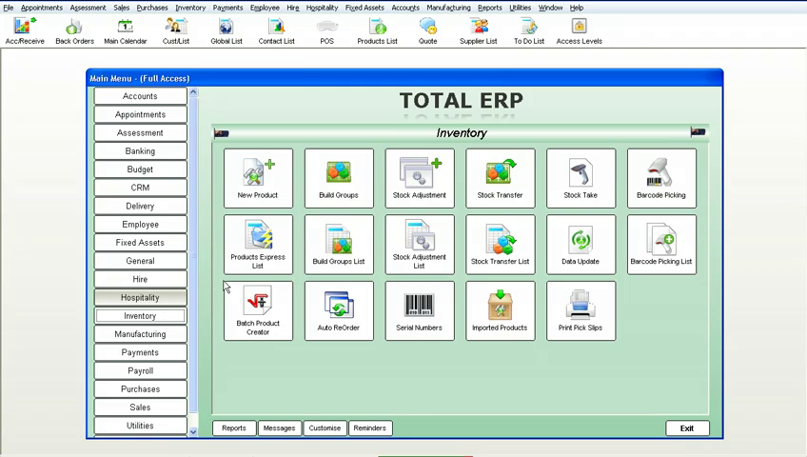

Features of  ERP Software's Inventory Management include the following:

* New Product
* Build Groups
* Stock Adjustment
* Stock Transfer
* Stock Take
* Barcode Picking
* Product Express List
* Build Group List
* Stock Adjustment List
* Stock Transfer List
* Data Update
* Barcode Picking List
* Batch Product Creator
* Auto ReOrder
* Serial Numbers
* Imported Products
* Print Pick Slips

### Barcode Picking

This module of **ERP Software** allows orders to be placed in the office, the warehouse then completes the order without touching the computer, by the use of a scanner. By scanning in their employee barcodes, the next prioritised picking slip will appear. **ERP Software** will then track how long it takes to pick the goods, and then how long it takes to pack the goods

### Build Groups

Also called a "Bill of Materials". This is where you can make a product from different, separate products. You can also have a group within a group or unlimited sub-products. No limits. Whenever one of these groups is sold, all the associated separate products are reduced by the number in the stock on hand list required to make the group.

### Product Express List

Complete details as required, to keep an accurate and extensive stock management database, even down to creating your own customisable fields and drop downs. Fully drillable allowing you to retrieve any information on a product down to an amazing detail level.

### Stock Transfers

Keeps a complete record of any stock transfers between warehouses, stores etc. will even track who did what transfer, and at what time they did it.

### Serial Number

Individual products can be tracked from purchasing to sales, with their own separate numbers. Keeps accurate records of exactly which customer has which product, when they brought it and who the supplier was that supplied it. Great for warranties etc.

### Data Updates

Prices can be altered on mass with the push of one button, by Department, Code, Group, etc. You can set adjustments as a fixed value or as a percentage change, as a positive or a negative. If you turn on a preference in **ERP Software**, any product cost change will automatically adjust the sell price, keeping the same margin as before the cost change.

### Stock Adjustments

Great for adjusting stock due to theft, lost stock or unknown. Simply assign it to an adjustment account and your stock balances and chart of accounts are kept accurate to the second.

**Stock Take**

These can be done by a number of methods. 1. Directly entering the count into the program. 2. By exporting out to Microsoft Excel and adjusting the spreadsheet in Microsoft Excel, then importing the spreadsheet back into **ERP Software** and assigning an adjustment value account. 3. By the use of a handheld unit, this will interface directly with **ERP Software**. With the addition of a scanner, stock takes become a breeze to do and what would normally take a team of people eight hours to complete, can be accomplished in less than two hours with the scanner unit

**Employee**

**ERP Software** helps you measure and increase employee productivity.  Real Time integration of  Jobs, Sales, Timesheets and Rosters within ERP Software means you can track, measure and respond immediately to fine tune employee activities .

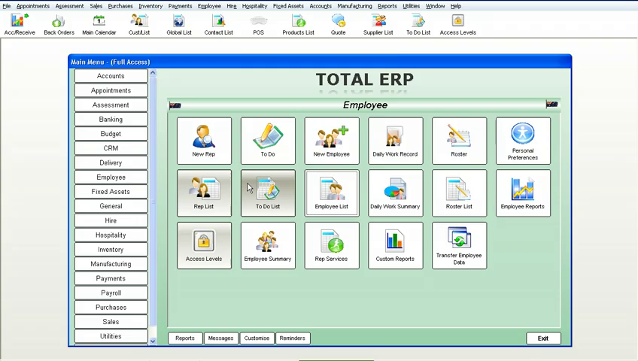

It includes

* New Rep
* To Do
* New Employee
* Daily Work Report
* Roster
* Personal Preference
* Rep List
* To Do List
* Employee List
* Daily Work Summary
* Roster List
* Employee Reports
* Access Levels
* Employee Summary
* Rep Service
* Custom Reports
* Transfer Employee Data

### New Employees

Complete details as required, to keep an accurate and extensive employee database or collection of information that is fully integrated with a complete business management and accounting system. This collection of information can be added to or deleted from depending on your requirements, even down to creating your own customisable fields and drop downs.

### Rosters

ERP Software has a fully integrated roster module, not only is it attached to the Employee, but it can be directly loaded from the roster into Payroll. Assign all forms of leave on the roster, such as sick and annual leave, for any or all employees, which again will flow, directly into payroll. Great for tracking which store and what times staff need to be at work.

### To Do List

Tasks can be assigned to different employees, who when logging on to their system, a screen will pop up to remind them to complete these tasks. These can be viewed and alter at any time and also reported on.

### Customise Reports

Add your own specific fields to categorise your Employees. These fields can be text fields as well as 'Drop Down' fields. By making them drop downs you force a certain value to be selected, thus making your database consistent with what is displayed. There is even an option that you can turn on or off, with these fields that prevents the form from being closed if one of the values has not been entered.

### Personal Preferences

Allows each employee to set their own personal preferences, without accessing vital data, or areas of 'No Access'. They can completely customise the way ERP Software looks for them even down to which fields the cursor stops on, including colours displayed and columns on reports that are seen.

### Representative Listing

Complete details as required, to keep an accurate Rep/Trainer database, a database or collection of information, that is fully integrated with a complete business management and accounting system, including a full calendar display screen, showing appointments and meetings for each and every Rep/Trainer. This collection of information can be added to or deleted from depending on your requirements, even down to creating your own customisable fields and dropdowns.

**Sales**

**ERP Software** gives you maximum flexibility, combined with rock solid control over every aspect of your sales processes and cycles from the very first contact with a prospect, all the way through to them becoming a customer.

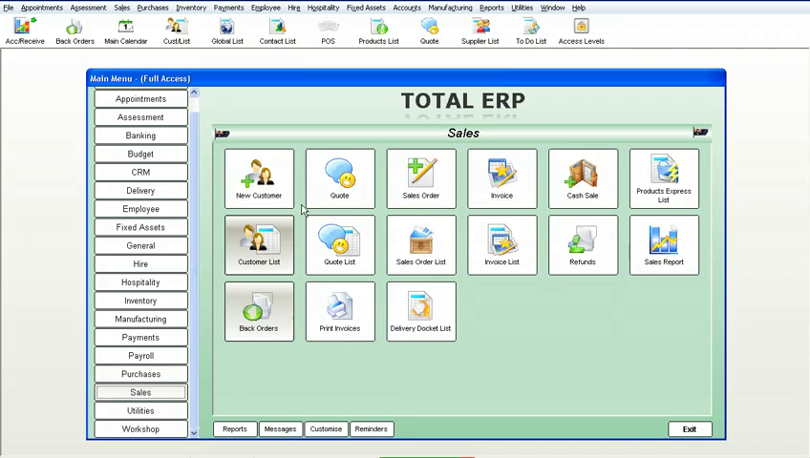

* New Customer
* Quote
* Sales Order
* Invoice
* Cash Sale
* Product Express List
* Customer List
* Quote List
* Sales Order List
* Invoice List
* Refunds
* Sales Reports
* Back Orders
* Print Invoice
* Delivery Docket List

### Customers

Complete details as required to keep an accurate customer database, which can be added to, or deleted from, depending on your requirements. The customer database is live to all areas of **ERP Software** which ensures that if any transaction involving a client is processed, the correct details including credit limits, pricing levels, past history, and contact and shipping details are automatically loaded and updated. No longer do you have to have multiple software packages to run your business.

### Customer List

An extensive and complete history of every quote, sales order, invoice, cash sale, statement, appointment etc that you have made with this customer. These can at any time be simply drilled into to open the original transaction that makes up the report. If you have the phone system connected to **ERP Software** this list will even include calls made to the customer.

### Quotes

Unlimited number per individual customer or job, with one button conversion to invoice, sales order, repair, another quote, or smart order. Any special price quoted on for a customer can be automatically stored and always used as that customer's price for that product. Can be faxed, emailed, or printed in multiple formats, all from the quote screen, as**ERP Software** has it's own built-in fax and email engine, so no external software is required to complete these operations.

### Quote List

Estimate sales by judging how likely obtaining the quote is, by using the status options to reflect the likelihood of making the sale.

### Sales Orders

Used as a confirmation of a sale prior to invoicing. **ERP Software** sales orders come with full picking slip and delivery docket capacity. These can also be easily converted to any number of options from invoices to smart orders etc.

### Cash Sales

Can be faxed, emailed or printed in multiple formats, all from the cash sale screen, as **ERP Software** has its own built-in fax and email engine, so no external software is required to complete these operations

### Invoicing

Can be faxed, emailed or printed in multiple formats, all from the invoice screen. As **ERP Software** has its own built-in fax and email engine, no external software is required to complete these operations.

### Refunds

Can be faxed, emailed or printed in multiple formats, all from the refunds screen, as **ERP Software** has its own built-in fax and email engine, so no external software is required to complete these operations.

### Delivery Dockets

Complete printout of all the information as required for the delivery of the customers goods.

# Workshop

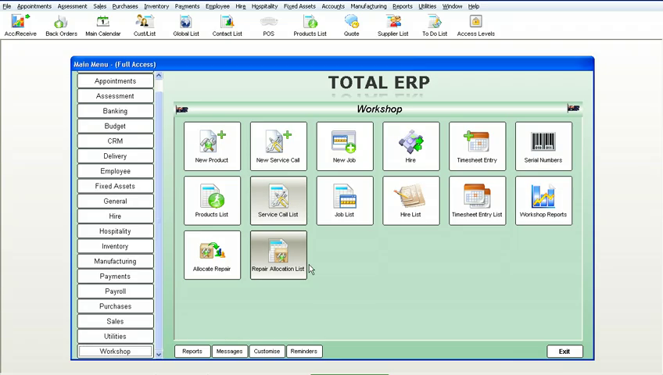

ERP Software gives you enormous flexibility and maximum control in managing all aspects of your workshop, servicing and maintenance requirements, from tracking warranty costs, on-site calls to automated scheduled servicing.  ERP is fully integrated to track all of your servicing inputs including parts, time and labour.

* New Product
* New Service Call
* New Job
* Hire
* Time sheet Entry
* Serial Numbers
* Product List
* Service Call List
* Job List
* Hire List
* Timesheet Entry List
* Workshop Reports
* Allocate Repairs
* Repairs Allocation List

### Repair Allocation List

Book in repair work with a client, internally or externally, these can be warranty or service calls etc.  Also track repair work for assets you own, rent or hire giving a complete breakdown of all costs involved with keeping that asset.

### Workshop Report

Full workshop management with reports including work-in-progress, staff costing, job costing, job profitability and stock control with the ability to barcode-scan in stock used for the jobs in the workshop.  Stock can be automatically ordered from the repair.

### Serial Number

Serial number tracking is active on all repairs allowing you to track full history on repaired items and warranty periods on any item.

### Time Sheets

Fully integrated with time sheet entries and payroll.  Great for tracking hours spent on jobs within the system.